Business Requirements

Raw and Cleaned Datasets and Code to Clean Data
Both the Raw(jlpt_vocab.csv) and Clean(jlpt_vocab_cleaned.csv) Datasets are available in the data folder. The data cleaning code is within the train_model.py file.
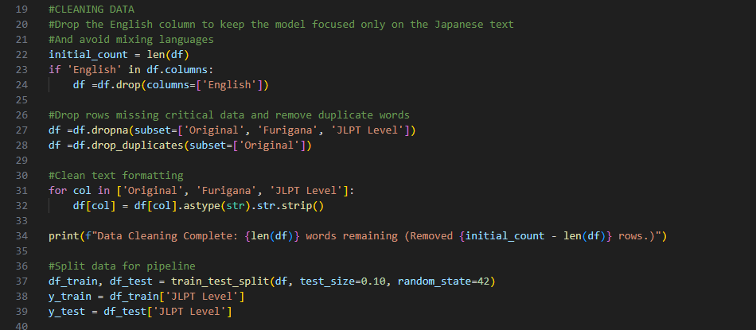

Data Analysis and Descriptive Data Product Code
The descriptive data product is the bar chart found in the training metadata checkbox on the dashboard. The Bar chart and corresponding code(descriptive_analysis.py):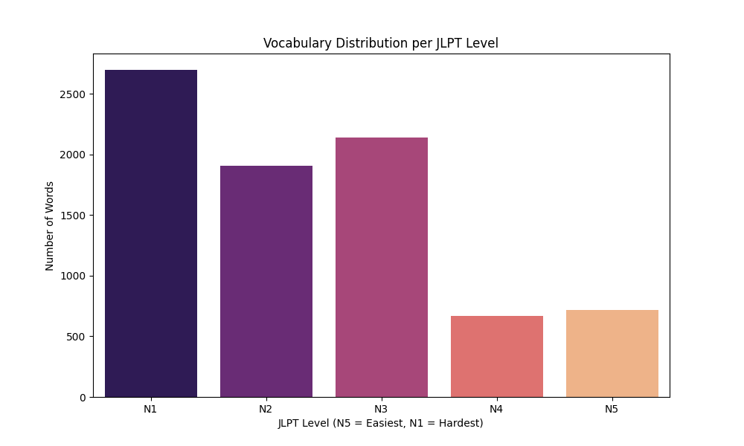

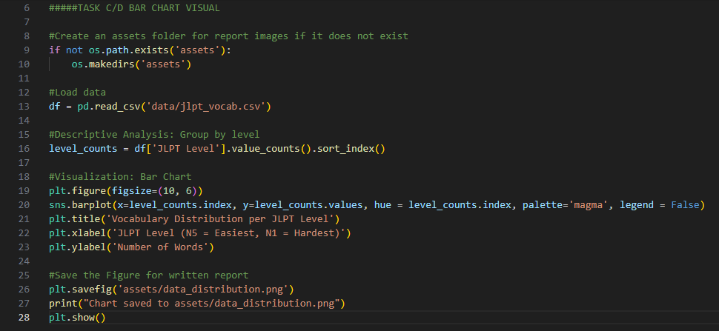Assessment of Hypotheses
The overall goal of a tool which accurately predicts the difficulty level of Japanese text and provides insight for language learners was achieved. The hypothesis of complex Kanji characters pointing towards higher difficulty was found to be true however the accuracy goal of >70% was unattainable. The actual model accuracy was determined to be ~42.41% Accuracy. This is more than twice the Accuracy of random guessing (5 options, 20% chance to be correct with any guess). This accuracy metric was abandoned in favor of making a more informative data product which breaks down its predictions and still reaches an accurate final overall difficulty score for the text as a whole using a heuristic Hiragana-veto system and a threshold ladder to choose the text’s overall difficulty based on the model’s predictions. Original Objectives and Hypotheses(Project Transmittal Letter and Proposal (Task A).docx):
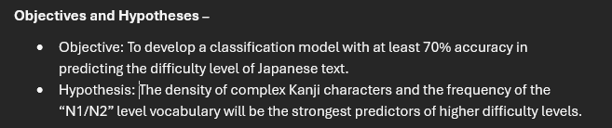

Visuals
The project contains three dynamic visuals and one descriptive visual of the training data. One requirement for the project was to show what data was known and what was a predictive vs descriptive conclusion by the model so to increase transparency to the user this is clearly labelled in the visuals. The three dynamic visuals are shown here (Note: These visuals will change with different user input. A paragraph from the JLPT N1 Level Sample Test was used for these images).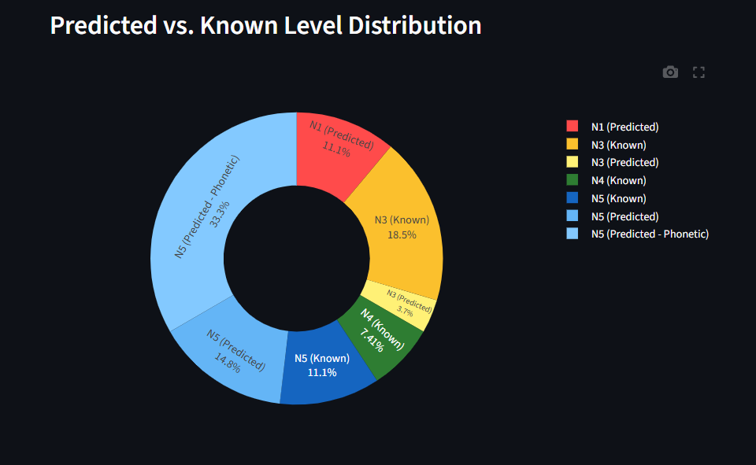
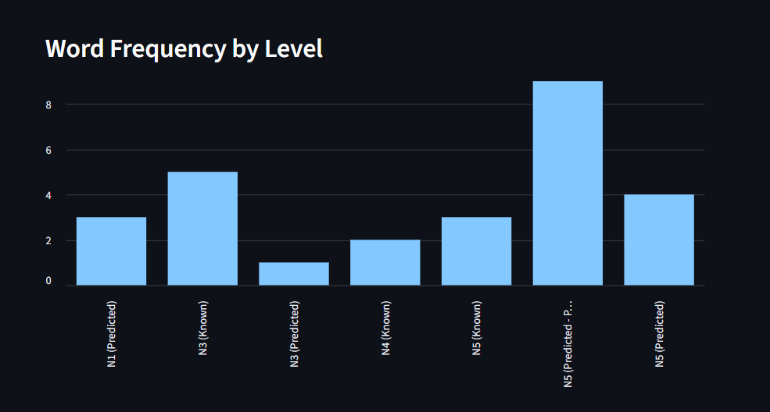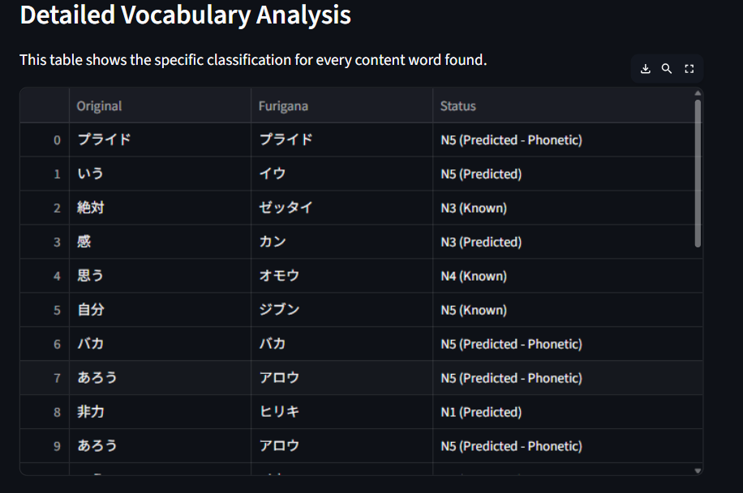

Accuracy Assessment
The final model had an accuracy of 42.41% when tested on 10% of the dataset which was held back from the training data. The final model was fairly balanced with only a slight bias towards the higher difficulty levels. The dashboard also has a checkbox which shows the Training data Bar Chart and the current model’s accuracy on demand within the dashboard.
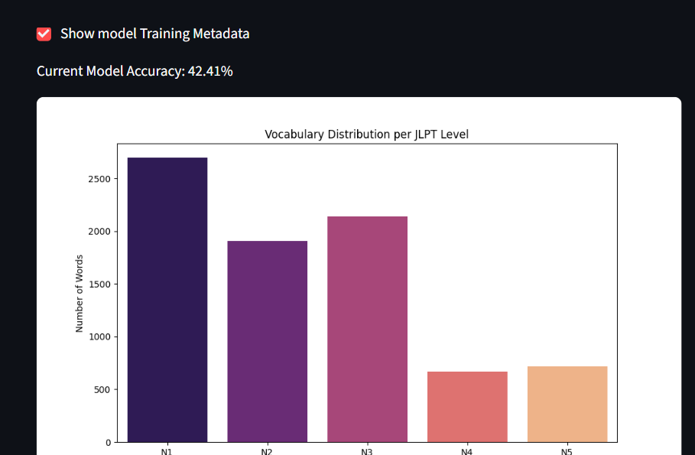
The final model’s accuracy assessment:
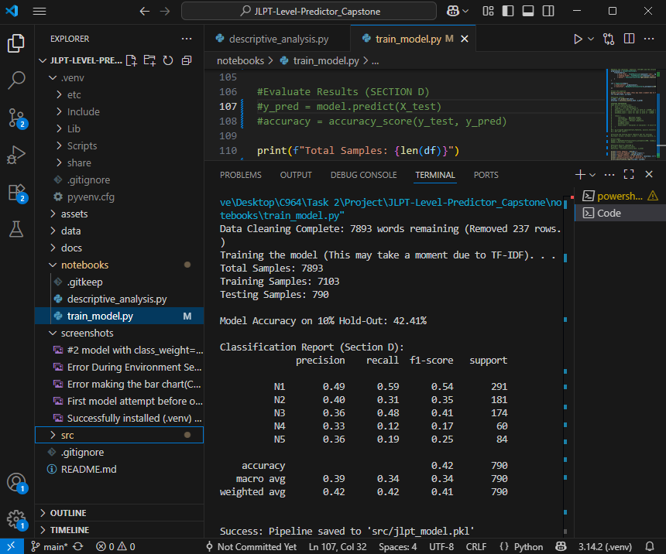
While the final model’s accuracy score was 42.14% the actual dashboard output will be significantly more accurate due to the additional Hiragana-veto logic heuristic and threshold ladder. This serves to increase end user functionality despite the lower than expected accuracy score.

Results of Testing, Revision, and Optimization
The first version of the model was fairly accurate (40.51%) but heavily biased towards the extreme difficulty levels (N1 and N5) performing poorly for most of the intermediate levels(N2, N3, and N4):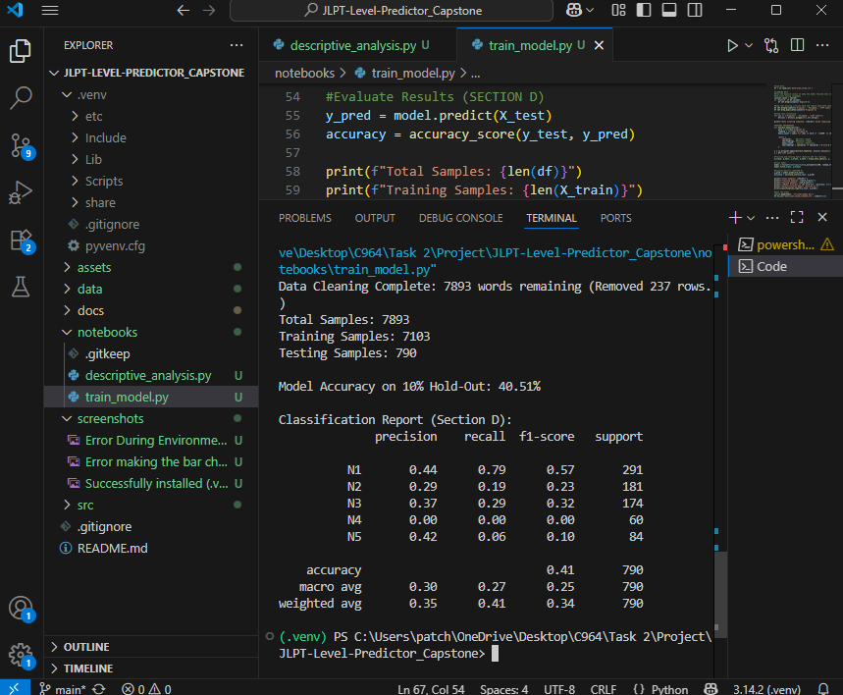
The next version had a worse overall accuracy (35.32%) but it was more balanced by setting the class_weight=’balanced’.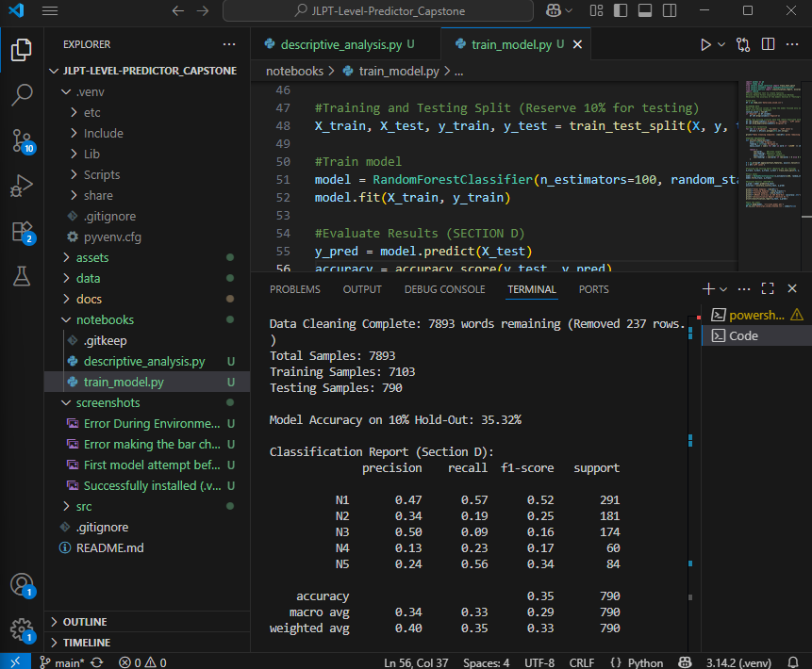
The next iteration was the final model. It implemented a Term Frequency-Inverse Document Frequency (TF-IDF) pipeline. This would look at specific words and evaluate their importance relative to the text as a whole. By adding this alongside the original manual features used for the Random Forest Classifier the accuracy was boosted to its final value of 42.41%. This optimization also remained balanced without any heavy bias towards any difficulty level. The final model accuracy assessment:
In addition to the optimizations made to the model there was also logic implemented in the dashboard to help improve the final overall difficulty rating. First is the Hiragana-Veto heuristic. In Japanese complex words are often written using a mixture of Hiragana/Katakana and Kanji. It is very rare for a high difficulty word to not have Kanji so logic was implemented to default predictions that do not have Kanji down to N5 if they were originally predicted at a high level (N1, N2, or N3). This Heuristic logic is denoted as N5 (Predicted – Phonetic) in the dashboard. 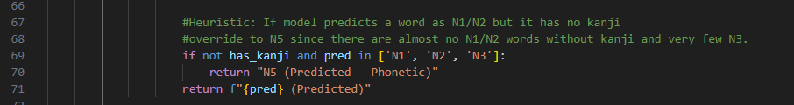Additionally, a threshold ladder was used for the final overall difficulty. This is because in the Japanese language many common words are lower difficulty but a sentence that is a higher difficulty will still need to use them to make sense. Things like the word for “To do” (する) are lower difficulty but commonly will appear alongside higher difficulty words for the sentence to be grammatically correct. Due to this factor we only look for a threshold of each level to determine difficulty. A N1 difficulty paragraph will have some N1 level words and words from each level below, a N5 paragraph will have little to no words from higher difficulties.
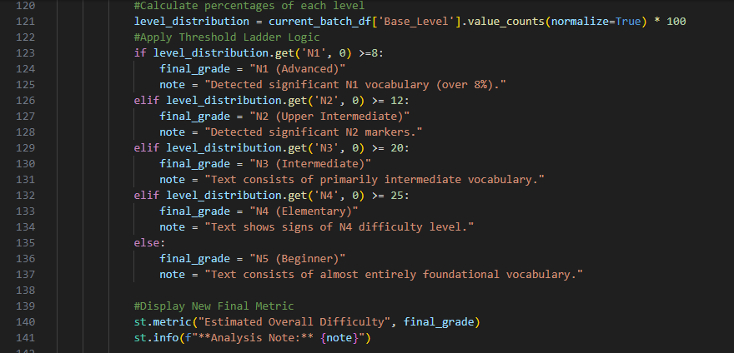

Source Code, Files, and Dashboard Features

Source Code
All of the source code and files are submitted as a .zip of the main project folder. It can also be cloned with the GitHub repository (https://github.com/davidrbritt/JLPT-Level-Predictor_Capstone.git) which was used for security and version control.

Dashboard Features and Implementation
Descriptive and Predictive methods:
- Descriptive Method - The application uses a frequency-based descriptive analysis of the JLPT vocabulary dataset. It generates a bar chart distribution profile of the known vocabulary levels (N1 – N5) to establish a baseline for the linguistic landscape of the data.
- Predictive Method – The project uses a Random Forest Classifer s its predictive method. This model analyzes character level features using manual feature implementation and a TF-IDF pipeline for Japanese text to predict the most likely JLPT difficulty level for vocabulary not found in the dataset.

Collected/Available Datasets: The primary dataset used is jlpt_vocab.csv. It is a large set of over 8,000 Japanese words categorized by their respective JLPT level. This dataset includes the Original Japanese text(Kanji/Kana), the Furigana(phonetic reading), and the target labels (JLPT N1-N5).
The application also collects user input. This data is dynamically used for real time analysis and to predict its JLPT level.
Decision Support Functionality: The application serves to support decisions for both Japanese learners and Japanese educators. It objectively quantifies reading material’s difficulty using the data-driven difficulty estimate, assisting their decision on choosing skill level appropriate lesson/study materials.
Featurizing, Parsing, Cleaning, and Wrangling Datasets: The project uses the Fugashi morphological analyzer (MeCab) to parse unspaced Japanese sentences into discrete tokens (words). Because Japanese text does not use spaces to separate words this parsing step is also the biggest data wrangling step as well since the tokenized words are now separated for processing.
For cleaning/wrangling, raw data is processed by removing non-essential English definitions, handling null values, and stripping whitespace.
The featurizing of the text data is done both through the TF-IDF pipeline at a character level and the visual complexity (Density of Kanji) are manually engineered to improve the model sensitivity.
Data Cleaning/Featurizing is done in train_model.py:
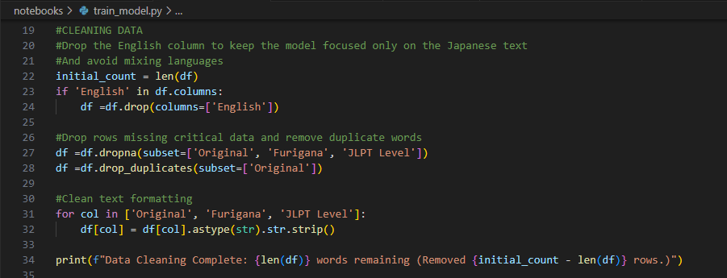
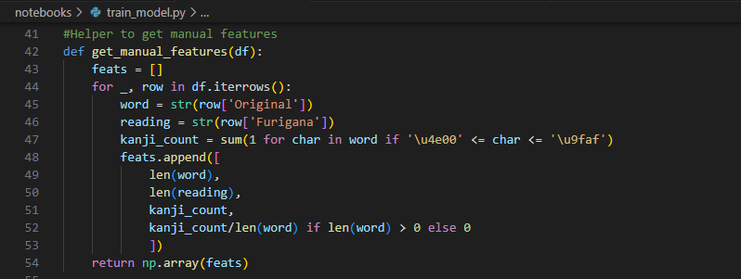
Parsing the user entered text is done in app.py:
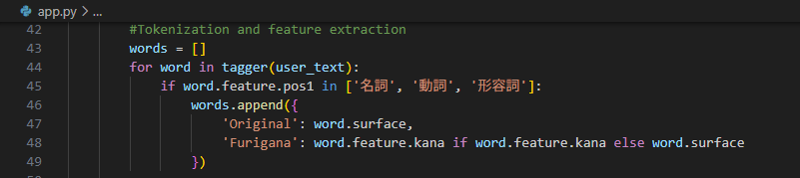
(The Japanese text in the code is part of the setup for Fushigi. It is saying to look for nouns, verbs, and adjectives.)
Code Supporting Data Exploration: The Exploratory Data Analysis (EDA) is performed through descriptive_analysis.py. It uses Pandas for data manipulation and Matplotlib/Seaborn for visualization. This code enables “Data Exploration” by identifying class imbalances in the dataset (The higher volume of more difficult words) which informed the decision to train the model with balanced class weights and to use heuristic optimizations in the final predictive model. 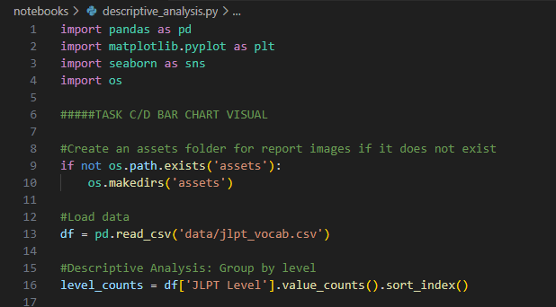
Data Visualization Functionality: The dashboard displays visualizations for the data found under the Show Model Training Metadata checkbox. This visualization is created in descriptive_analysis.py and the image is saved to assets/data_distribution.png.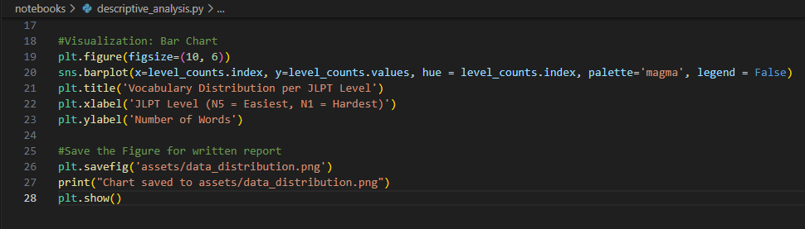
Interactive Queries: The dashboard supports interactive queries through the user text input field, the ‘Analyze Text’ button, and the Show Model Training Metadata checkbox. This code is all handled in the app.py file:
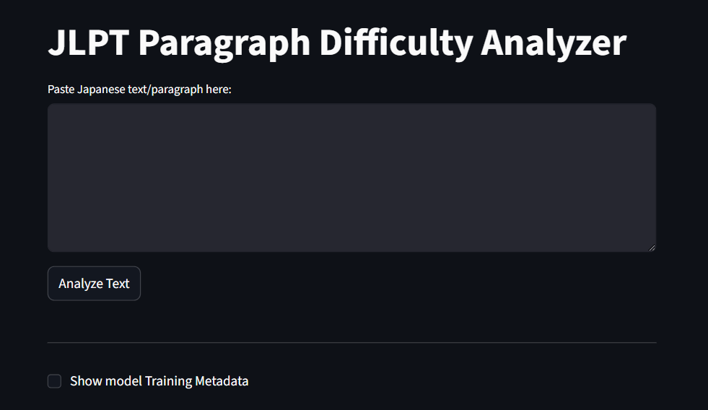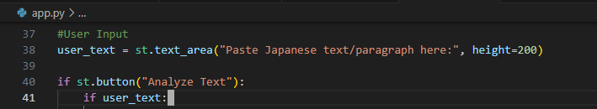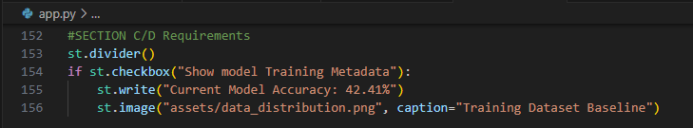
Machine Learning Code: The machine learning code is created in the train_model.py file and saved in src/jlpt_model.pkl:
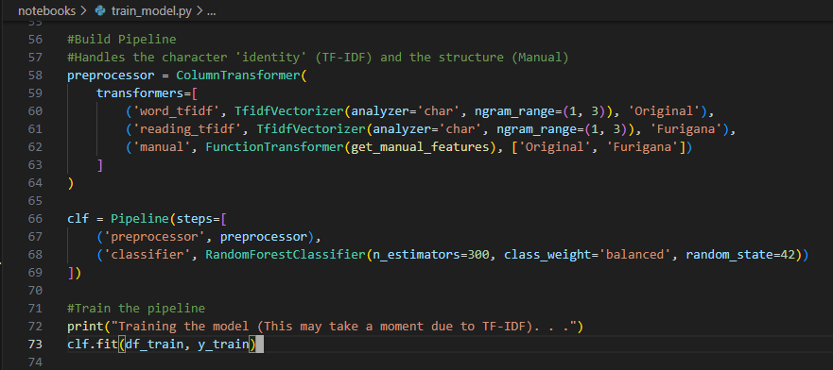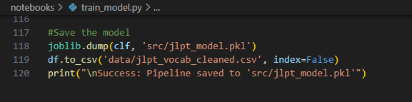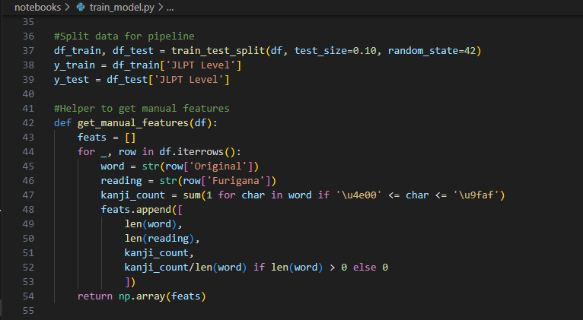
Accuracy Evaluation Code: The Accuracy Evaluation and printout code is found in train_model.py:
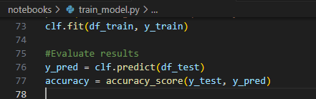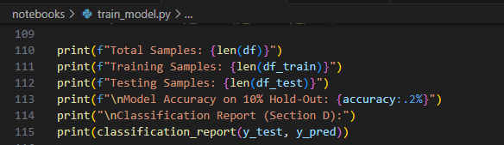
Project Security: The project uses standard security measures including a .gitignore file which specifies local development files to exclude from the GitHub repository to prevent unauthorized access. The project also does not “phone home” any of the user entered text data preventing data entered from ever being accessed by an unauthorized individual. The project also uses a python .venv virtual environment to make installation easy and sandbox the project from the development computer.
Project Maintenance: The project uses industry standard version control through GitHub for easy maintenance. There is also extensive documentation included in the main project folder within the docs/ folder and the README.md file. The project includes a requirements.txt file so the environment can be easily rebuilt. The model can also be retrained with train_model.py for future versions if a more extensive dataset becomes available.
User-Friendly Dashboard with three visualization types: The Dashboard features three intuitive visualizations. There is a dynamic Pie chart for the percentage of each level broken down by predicted or known values, dynamic bar chart number of words detected per level, and a dynamic table showing a detailed analysis of each word that the model analyzed from the user’s text input showing its Original text, Reading(Furigana), and the level (Either predicted or known). For visuals see above section titled “Visuals”. The Dashboard text input field with sample text entered (Implemented in app.py):
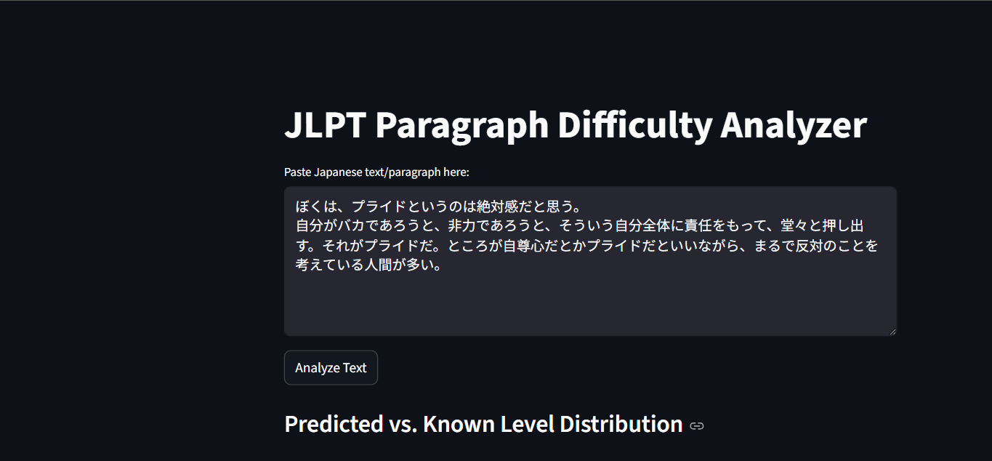
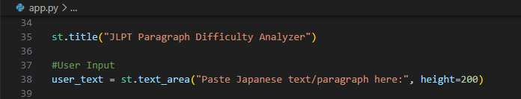

Quick Start Guide
See README.md in the project folder for the project’s quick start guide.

